ERASMUS + INTERNATONAL WEEK AT WSBPI „APEIRON”
– POSTER SESSION
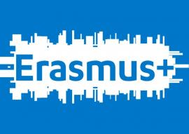
Date: 7–8 October 2020
Venue: Aparthotel Vanilla, Bobrzyńskiego 33, Krakow, Poland
As part of Erasmus+ International Days at University of Public and Individual Security „Apeiron” in Krakow, on 7–8 October 2020 a poster session will take place. We invite you to take part in it and submit proposals for posters.
Recommended topics:
- „Immigration crisis and cultural clash”
- „Opportunities for social and international security connected with the mobility of students and researchers”
- „Erasmus+: an answer to the challenges of cultural clash”
- „Experiences and good practices in Erasmus+ programme: the case of our institution”
Poster abstracts (100–200 words in length), prepared in English, are to be sent by 2 October 2020 to the address science4@apeiron.edu.pl
Posters should be prepared in English, in A1 format. Printing, choice of the preparation technique, transportation to the venue and fixing the posters at the facilities prepared for this purpose in the foyer are the responsibilities of the Authors.
Each poster should contain:
- title
- author info: name, surname, affiliation
- introduction
- the main body: text, illustrations, photographs, figures
- conclusions
The posters will be displayed in a well-visible place in the venue’s foyer and will be available to the public all the time during the event:
- 7 October 2020, 10:30–18:00
- 8 October 2020, 9:00–13:30
Due to this, authors are asked to install the posters till 9:30 on Wednesday 7 October 2020.

